Name ________________________________________ Date: _______________ Period:_____________________

Number Systems and Characteristics of Functions
Into which group does each number go?
 | Natural | Whole | Integers | Rational | Irrational | Real | Imaginary | Complex
22.5
3/8
$$\sqrt[3]{14}$$
4-7i
13i
-18
$$\sqrt{-18}$$
2i-18.4
0
9/4

Find the domain and range and intervals of increasing and decreasing.
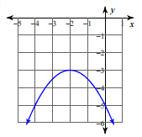
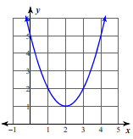
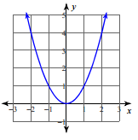

D = _______________ D = _______________ D= _______________
R = _______________ R = _______________ R = _______________
Inc = _________________ Inc = _________________ Inc = _________________
Dec = ________________ Dec = ________________ Dec = ________________
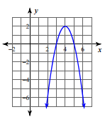
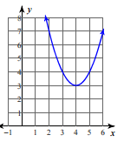
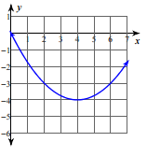

D = _______________ D = _______________ D= _______________
R = _______________ R = _______________ R = _______________
Inc = _________________ Inc = _________________ Inc = _________________
Dec = ________________ Dec = ________________ Dec = ________________

