1. Factor completely:  $$x^{2}-2x-24$$ | 2. Factor completely:  $$2x^{2}+6x-36$$
3. Factor completely:  $$x^{2}+64$$ | 4. Factor completely:  $$50x^{2}-8$$
5. Factor completely:  $${2x}^{2}-9x +10$$ | 6. Factor completely:  $$3x^{2}+4x-15$$
7. Factor completely:  $${x^{3}-2x}^{2}-9x+18$$ | 8. Factor completely:  $${9x}^{2}+100$$
9. Factor completely: | 10. Simplify completely:  $$\left(14+4i\right)-(11-8i)$$
11. Simplify completely:  $$(3-6i)(5+7i)$$ | 12. Simplify completely:  $${(3-6i)}^{2}$$
13. Simplify completely:  $$\frac{3-2i}{5+i}$$ | 14. Simplify completely:  $$-\frac{4}{5i}$$

15. For the following graph, find the domain, range, intervals of increase and decrease, extrema, y-intercept, the roots, the axis of symmetry, and the end behavior.  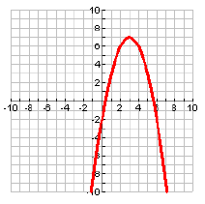  Domain:____________ Range:____________  INC:______________ DEC:________________  Extrema:_______________________________  Y-intercept:_____________________________  Roots:____________ Axis of Sym:__________  $$x →∞, f\left(x\right) →$$  $$x →- ∞, f\left(x\right)→$$ | 16. Sketch a graph with the following characteristics:  Extrema (1, -2)  Increasing $(1, ∞)$  Decreasing $(-∞, 1)$  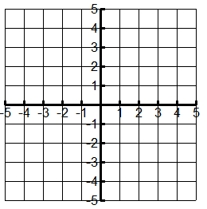  Extrema (3, 2)  Roots at (1, 0) (5, 0)
Into which group or groups does each number go?
 | Natural | Whole | Integers | Rational | Irrational | Real | Imaginary | Complex
-11
$$\sqrt{13}$$
3 – 2i

