### Name: __________________________________________ Date: _____________________________

**Even & Odd Functions**

**Algebraically: Even, Odd, Neither?**

* A function is **even** if 
  + **_________________________________________________________________________**
* A function is **odd** if 
  + **_________________________________________________________________________**
* A function is **neither** if
  + **_________________________________________________________________________**

**Graphically: Even, Odd, Neither?**

* A function is **even** if
  + **_________________________________________________________________________**
* A function is **odd** if
  + **_________________________________________________________________________**

**Examples: Even, Odd, Neither?**

1. 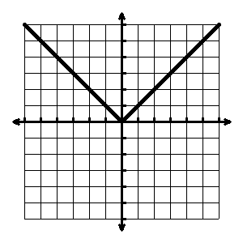****
2. 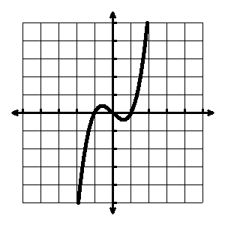****
3. 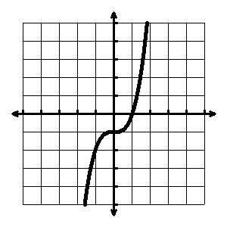****
4. 
5. 
6. 

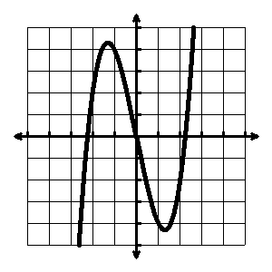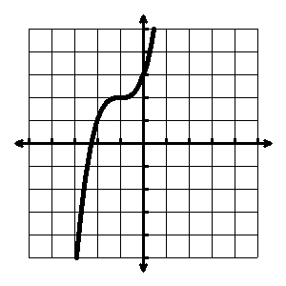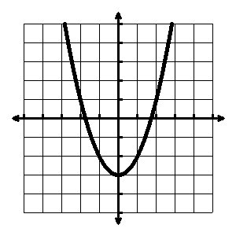Tell whether the function is even, odd, or neither.



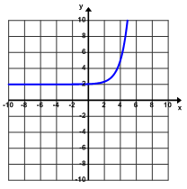

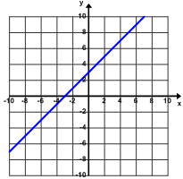

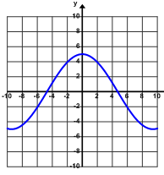



1. 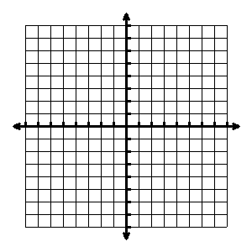Can a linear function ever be even or odd? If so, sketch an example.
2. Can an exponential function ever be even or odd? If so, sketch an example.