**3A.6 – Polynomial Characteristics Test Review Name: ____________________________________**

**GSE Algebra II Date: ________________**

**1. Answer each of the following questions for the graph (estimate the zeroes):**

|  |  |
| --- | --- |
| Domain: | Range: |
| Increasing | Decreasing: |
| x-intercepts: | y-intercept: |
| Rel. Max: | Rel. Min: |
| Abs. Max: | Abs. Min: |
| End Behavior: | |
| Min. degree | Sign of leading Coeff. |
| Symmetry: | |

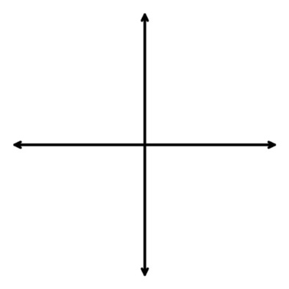**2. Sketch the graph by hand given that the zeroes are -3, -1, and 2. Then, answer each of the following questions for the graph. **

Domain:_____________ # of Zeros :_______________

# of Extrema :____________

**3. Determine the end behavior and maximum number of extrema (u-turns):**

|  |  |
| --- | --- |
|  |  |

**4. Determine if the function is even, odd, or neither:**

a) 

b) 

|  |  |  |
| --- | --- | --- |
| **5. State the range & # of zeros for each of the following polynomials** | | |
|  | |  |
| **6. State the sign of the leading coefficient & the if the degree is even or odd:** | | |
|  |  | |

**7. True or False:**

1. The **domain** of a polynomial function is always . _________
2. The **range** of a quadratic polynomial function is always . _________
3. Cubic polynomials never have an absolute minimum or maximum. _________
4. For a polynomial, it is possible to have a relative max and an absolute max. ___________

**Solve the following polynomial inequalities: (final answers in interval notation)**

**8.** 

**9.** 

**10.** 

**11.** 