|  |  |  |  |
| --- | --- | --- | --- |
| **Vertical Asymptotes** | **X-Intercepts** | **Y- Intercept** | **Horizontal Asymptotes** |
|  |  |  |  |

1. Graph

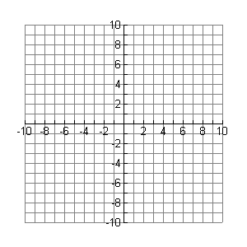

|  |  |
| --- | --- |
|  |  |
|  |  |
|  |  |
|  |  |
|  |  |
|  |  |



_________

_________

HA_____________

VA_____________

1. Graph

|  |  |
| --- | --- |
|  |  |
|  |  |
|  |  |
|  |  |
|  |  |
|  |  |





_________

_________

HA_____________

VA_____________

1. Graph

|  |  |
| --- | --- |
|  |  |
|  |  |
|  |  |
|  |  |
|  |  |
|  |  |





_________

_________

HA_____________

VA_____________

1. Graph

|  |  |
| --- | --- |
|  |  |
|  |  |
|  |  |
|  |  |
|  |  |
|  |  |





_________

_________

HA_____________

VA_____________

|  |  |
| --- | --- |
|  |  |
|  |  |
|  |  |
|  |  |
|  |  |
|  |  |

1. Graph





_________

_________

HA_____________

VA_____________