**Writing rational functions given characteristics:**

1. V.A. – x=________ and x=________
2. V.A. – x=________ and x=________

H.A. – y=________

1. H.A. - y=________ and y-intercept ____________

**Holes:** An open ______________ on the graph, (x,y). X is found from what _________________ after factoring. Y is found by _____________________ to the _____________ equation.

**Domain:** All Reals, except ___________________ & _____________________________.

**Range:** All Reals, except ___________________

& _____________________________.

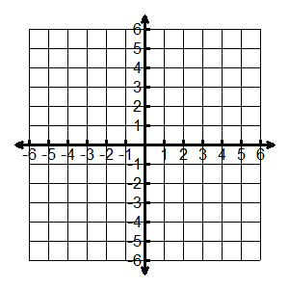

1. 

V.A: _____________

H.A.: _____________

x-int(s).: __________

y-int: ______________

Hole: ______________

Domain: _______________

Range: ________________

x y

1. 

V.A: _______________

H.A.: _______________

x-int(s).: _____________

y-int: ________________

x y

Hole: ____________

Domain:

___________________

Range:

___________________

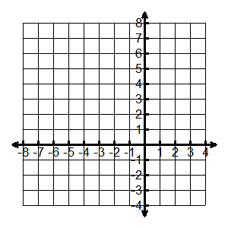

1. 

V.A: _______________

H.A.: _______________

x-int(s).: _____________

y-int: ________________

x y

Hole: ________________

Domain:

_______________________

Range:

_______________________

