**Slant Asymptotes:** If the degree on the _______________ is _________________________ higher than the degree on the ________________________, then the function has a slant asymptote, __________________.

* Use _____________________________ to find the equation.

Ex 1. 

Ex 2. 

Ex 3. What if ?

**Increasing & Decreasing:**  ____________________, read from left to right.

**Only use _______________________.**

1. 

V.A: _____________

H.A.: _____________

S.A.: _____________

x-int(s).: __________

y-int: _____________

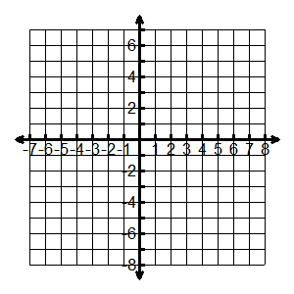

Hole: ____________

Inc: ______________

Dec: _____________

Domain: __________

Range: ___________

1. 

V.A: _____________

H.A.: _____________

S.A.: _____________

x-int(s).: __________

y-int: _____________

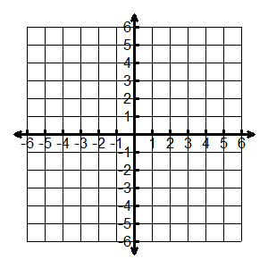Holes: ____________

Inc: ______________

Dec: _____________

Domain: __________

Range: ___________

1. 

V.A: _____________

H.A.: _____________

S.A.: _____________

x-int(s).: __________

y-int: _____________

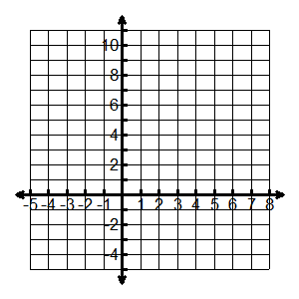

Holes: ____________

Inc: ______________

Dec: _____________

Domain: __________

Range: __________