Name: ________________________________________________ Date: _______________________

# **Characteristics of Functions**

1. 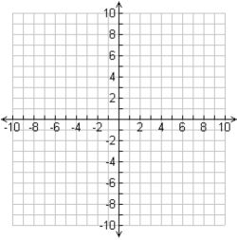
   1. Domain: __________
   2. Range: __________
   3. Extrema: __________
   4. Axis of Sym: __________
   5. Increasing: ________
2. Decreasing: __________

g. Y-Intercept­­­­­­­­­­­­­­­­­:___________ h. Solutions:______________

i. End Behavior: 

1. 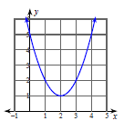
   1. Domain: __________
   2. Range: __________
   3. Extrema: __________
   4. Axis of Sym: __________
   5. Increasing: ________
2. Decreasing: __________

g. Y-Intercept­­­­­­­­­­­­­­­­­:___________ h. Solutions:______________

i. End Behavior: 

1. 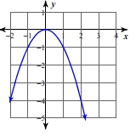
   1. Domain: __________
   2. Range: __________
   3. Extrema: __________
   4. Axis of Sym: __________
   5. Increasing: ________
2. Decreasing: __________

g. Y-Intercept­­­­­­­­­­­­­­­­­:___________ h. Solutions:______________

i. End Behavior: 

1. 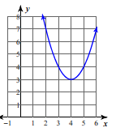
   1. Domain: __________
   2. Range: __________
   3. Extrema: __________
   4. Axis of Sym: __________
   5. Increasing: ________
2. Decreasing: __________

g. Y-Intercept­­­­­­­­­­­­­­­­­:___________ h. Solutions:______________

i. End Behavior: 

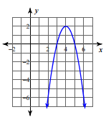

5. 

a. Domain: ___________ b. Range: _______________

c. Extrema: ___________ d. Axis of Sym: ___________

e. Increasing: _________ f. Decreasing: ___________

g. Y-Intercept­­­­­­­­­­­­­­­­­:___________ h. Solutions:______________

i. End Behavior: 



6. 

a. Domain: ___________ b. Range: _______________

c. Extrema: ___________ d. Axis of Sym: ___________

e. Increasing: _________ f. Decreasing: ___________

g. Y-Intercept­­­­­­­­­­­­­­­­­:___________ h. Solutions:______________

i. End Behavior: 