Name:___________________________________________ Date: ______________________

**End Behavior:**

Look _______________ and ______________, to figure out what’s happening ______________ and ___________.



**Graphically:**









**Algebraically:**

1. 



1. 



1. 



**Extrema:** are _________________ in the graph.

* If you are given a ______________, take the turns and __________ 1 to get the least possible degree of the polynomial.



Least Possible Degree:

* If you are given the _________________, take the degree and _______________ 1 to get the number of extrema.

f(x) = 2x3 – 3x2 + 5

Number of Extrema:

**Graphically, what is the least possible degree?**

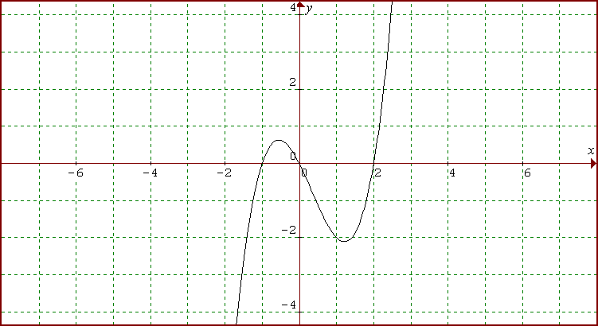

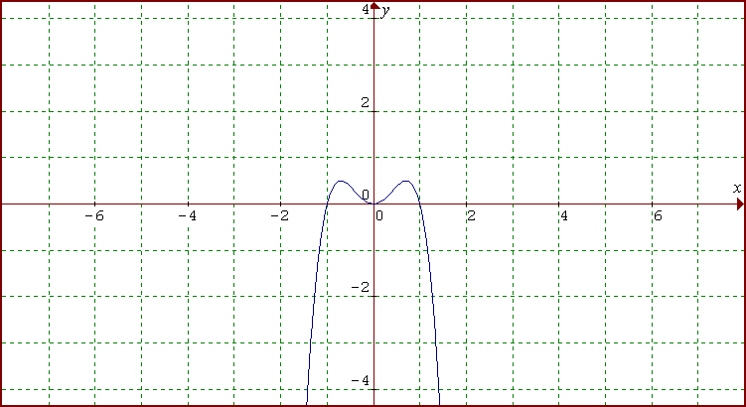

**Algebraically, what is the number of extrema?**

1. 
2. 
3. 

**Sketching:** Given the polynomial and zeros, sketch a graph and determine the characteristics

1. 

# of Zeros: __________ Y-Int: _____________



1. 

# of Zeros: __________ Y-Int: _____________

