1. Graph 

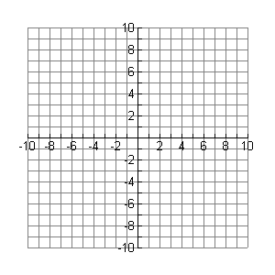

_________ HA_____________

_________ VA_____________

1. Graph 



_________ HA_____________

_________ VA_____________

1. Graph 



_________ HA_____________

_________ VA_____________

1. Graph 



_________ HA_____________

_________ VA_____________