Name: _____________________________________ Date: ____________________

Find the transformations:

1. 
2. 
3. 
4. 
5. 
6. 

Find the asymptotes:

1. 
2. 
3. 
4. 

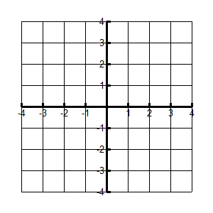State 3 points on Graph______________________________

Domain___________ Range_____________

Asymptote___________ Increasing or Decreasing

X-intercept __________ Y-intercept ___________

End Behavior 

1. 

State 3 points on Graph______________________________

Domain___________ Range_____________

Asymptote___________ Increasing or Decreasing

X-intercept __________ Y-intercept ___________

End Behavior 

1.  Transformations: ___________________________________

State 3 points on Graph______________________________

Domain___________ Range_____________

Asymptote___________ Increasing or Decreasing

X-intercept __________ Y-intercept ___________

End Behavior 

1.  Transformations: ___________________________________



State 3 points on Graph______________________________

Domain___________ Range_____________

Asymptote___________ Increasing or Decreasing

X-intercept __________ Y-intercept ___________

End Behavior 