Name:_________________________________ Date: ____________________

Normal Curve:

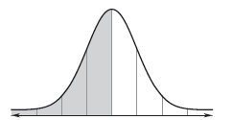
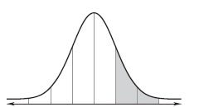

- A normal distribution has a mean of 18 and a standard deviation of 3. Find the probability that a randomly selected x-value from the given distribution is in the interval.

- The heights of 3000 women at a particular college are normally distributed with a mean of 65 inches and a standard deviation of 2.5 inches

- About what percent of college women have heights below 70 inches?

- About how many college women have heights between 60 inches and 65 inches?

- A particular leg bone for dinosaur fossils has a mean length of 5 feet with standard deviation of 3 inches. What is the probability that a leg bone is less than 62 inches?

- The weight of chocolate bars from a particular chocolate factory has a mean of 8 ounces with standard deviation of .1 ounce. What is the probability that a randomly selected bar is between 7.85 and 8.15 ounces?

- The grades on a statistics midterm exam were normally distributed with a mean of 72 and a standard deviation of 8.

  - What is the proportion of students received a B grade.

  - What is the probability that a randomly selected student received between a 65 and 85?

  - What is the proportion of students that failed the exam?

