Name:_________________________________ Date: ____________________

**Z-Score:**

The number of ______________________________ the x-value lies above or below the _________.

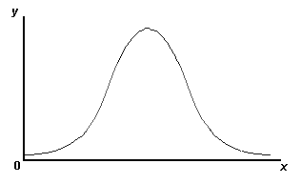



***We can use z-score to compare two different sets of data***

**Ex. 1** A normal distribution has a mean of ________ and a standard deviation of ____________. Find the z-score.

**Ex. 2** A normal distribution has a mean of ________ and a standard deviation of ____________. Find the z-score.

**Ex. 3** Test scores on the last major test were normally distributed with a mean of 60 and a standard deviation of 9. You made a 54. (Yikes!)

* 1. What is the z-score associated with your grade?
  2. Your very kind teacher decided to curve the grades. She changed the mean to a 70 and the standard deviation to 5 but kept the z-scores the same. What is your new score?

**Ex. 4** Bill plays for the Silver Hawks basketball team. He scores 8 points a game. The team average is 6.5 points per game with a standard deviation of 1.0.

His friend Ryan plays for the Red Hawks basketball team. He scores 8 points per game. The team average is 5 points per game with a standard deviation of 1.5.

They argue that they are equally as good as each other. Are they right? Who is more valuable to their team?

**Ex. 5** At Eastview Pizza, orders for delivered pizza are free if the pizza is delivered more than 45 minutes after it is ordered. It always takes 15 minutes to prepare a pizza at this restaurant, so you have to add this to each driver’s mean delivery time. This table shows statistics on the delivery times for two drivers.

Which driver is more likely to give away free pizzas?



**Ex. 6** Lewis earned 85% on his biology test & 80% on his history test. In his biology class the mean was 79% with a standard deviation of 3. In his history class the mean was 76% with a standard deviation of 4.

1. What percentage of the class was below Lewis in the biology class?
2. What percentage of the class was below Lewis in the history class?
3. On which test did he do better compared to the rest of the class?