Name _________________________________ Date _______________

1. Use the list of data to calculate the following:

77, 80, 98, 67, 85, 82, 85, 75, 93, 68

* 1. ___________ mean
  2. ___________ median
  3. ___________ mode
  4. ___________ range
  5. ___________ standard deviation
  6. Box and whisker Plot

___________________________________________

1. Use the list of data to calculate the following:

37, 21, 46, 36, 47, 52, 98, 31

a. ___________ mean

b. ___________ median

c. ___________ mode

d. ___________ range

e. ___________ standard deviation

f. Box and whisker Plot

___________________________________________

1. 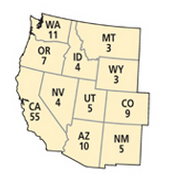The numbers of electoral votes in 2004 for 11 western states are shown.

Find the mean and the standard deviation of the data. Identify any outliers, and describe how they affect the mean and standard deviation.

1. This table shows the average low temperature, in ºF, recorded in Macon, GA, and Charlotte, NC, over a six-day period.

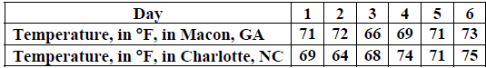

Which conclusion can be drawn from the data? (Multiple Choice)

1. The interquartile range of the temperatures is the same for both cities.
2. The lower quartile for the temperatures in Macon is lower than the lower quartile for the temperatures in Charlotte.
3. The mean and median temperatures of Macon were higher than the mean and median temperatures of Charlotte.
4. The upper quartile for the temperatures in Charlotte was lower than the upper quartile for the temperatures in Macon.
5. 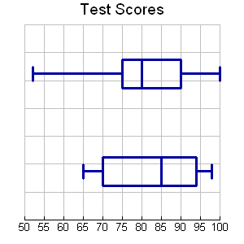Which statement below is NOT true?
6. 2nd period had the highest score on the test

**2nd**

1. The median for 2nd period is 5 less than the median for 3rd
2. The LQ for 2nd period is 5 less than LQ for 3rd period
3. The UQ for 3rd period is 94

**3rd**

1. Fill in the blanks:
   1. The median for 2nd period is _____
   2. The median for 3rd period is _____
   3. The lowest score for 3rd period is _____
   4. The lower quartile for 2nd period is _____
   5. The spread of the middle 50% for 2nd period is _______
2. Mr. Suttle would like to determine if the cafeteria should sell snacks during non-lunch periods. Which sampling method is most likely to yield an accurate prediction of the population?
   1. Survey every 20th student who enters the cafeteria during lunch
   2. Survey 50 random students each from the 9th, 10th, 11th, and 12th grade
   3. Survey the first 25 students that walk into school
   4. Survey all the seniors.
3. Write an example of a self-selected Survey. Be creative!
4. In a survey of 50 Hillgrove students, 22 said that they plan on attending the next basketball game. The school has 2300 students, predict the number of students attending the game.

**Explain whether each situation is an experiment or an observational study**

1. A researcher asks 1000 randomly chosen adults to list the average number of hours of sleep they get per night for six months and examines whether the amount of sleep affects the number of colds the adults get.
2. A grocery store manager wants to know how much more of a certain food item will sell if he lowers the price by 10%.

**The study below is a randomized experiment. Describe the treatment, the treatment group, and the control group.**

1. An engineer wants to know if a fuel additive will affect the fuel efficiency of a car. He recruits 40 volunteers and randomly assigns them to two groups. One group fills their cars with gas with the additive. The other group fuels their cars with plain gas. The group that uses the additive sees a 5% decrease in fuel efficiency.
2. You have a set of data. The mean of the data is 32 with a standard deviation of 4. Find the following probabilities:
3. ___________ P(X ≥ 28)
4. ___________ P(X ≤ 24)
5. ­­­­­­___________ P( X is at most 36)
6. ___________ P(X ≤ 24 or X ≥ 36)
7. ___________ P(24 ≤ X ≤ 40)
8. The mean of a set of data is 51. A number X is picked at random and the probability that X ≥ 54 is 16%. What is the standard deviation of the data?
9. The mean of a set of data is 225. A number X is picked at random and the probability that X < 195 is 0.15%. What is the standard deviation of the data?
10. The mean of a set of data is 225 and the standard deviation is 10. Find these probabilities:

a. ___________ P( X ≥ 235)

b. ___________ P ( X ≤ 235)

c. ___________ P( X ≥ 215)

d. ___________ P(205 ≤ X ≤ 245)

e. ___________ P( X ≤ 215 or x ≥ 245)

1. The mean of a set of data is 51 and the standard deviation is 4. Find these probabilities:
2. ___________ P( X ≥ 54)
3. ___________ P ( X ≤ 48)
4. ­­­___________ P( X ≥ 57)
5. ­­­­­­­­­­­___________ P(48 ≤ X ≤ 60)
6. ___________ P( X ≤ 45 or x ≥ 51)
7. A group of 625 students has a mean age of 15.8 years with a standard deviation of 0.6 years.  The ages are normally distributed.  How many students are younger than 16.2 years?

**Find the Margin of Error for a survey based upon the sample size. Round to the nearest tenth of a percent.**

1. 396
2. 13,567

**Find the sample size required to achieve the given margin of error. Round your answer to the nearest whole number.**

1. ±9.5%
2. ±14.3%

**Cell Phones:** In a survey of 2,532 teenagers, 68% said that they spend 10 to 12 hours a week on Twitter.

1. What is the margin of error for this survey? Round to the nearest tenth.
2. Give an interval that includes the margin of error.