Name___________________________________ Date _________________
Tell the type of sample each situation represents.
You are interested in finding out if students at your school think that fine arts programs are receiving enough funding. You decide to:

- use a written survey that you give to people sitting at your lunch table.

- put a table at the entrance to the cafeteria with a sign directing students to complete the survey if they want to and drop it in the box.

- randomly selected students from each of the 4 grades.

- ask all the juniors and freshmen.

- put all names in a hat and draw ½ the names out to ask.

- Dr. Jones wants to see whether the gender of members in a tribe in the Amazon plays a role in the order in which they are served their meals. Is this an observational study or experiment?

- Dr. Jones also wants to see whether the monkeys in the area grow larger when eating their native diet or when given manufactured monkey pellets. Is this an experiment or observational study? What are the treatment group, control group, and treatment?

- Draw a normal curve for a normal distribution with a mean of 30 and standard deviation of 5. Label all the areas under the curve.

Give the percent of the area under the normal curve represented by the shaded region:
- __________

- __________

- One hundred students out of 1200 at a school were surveyed. Fourteen said they had an after school job. Predict the number of students in the population that would answer similarly.

- A normal distribution has a mean of 42 and a standard deviation of 3. Draw a normal curve to represent this.

a) What percentage of values lie between 33 and 45?___________
b) What percentage lie above 48?______________
c) What percentage lie below 35?____________

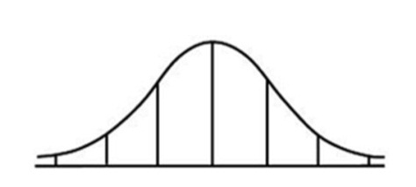
- The high temperatures for days in January are normally distributed with a mean of 38ºF and a standard deviation of 5 degrees.

a) What is the probability that the high temperature for a day will be at most 46º?
b) What is the probability that the high temperature will be a least 36º?
c) What is the probability that the high temperature will be between 32 and 44 degrees?

- The mean age of reading the War of the Worlds is 18 with a standard deviation of 1 in the city of Fargo North Dakota that has a population of 10,000.

- How many people would have read the book between the ages of 17 and 19?

- How many people would have read the book between the ages of 16 and 20?

- How many people would have read the book between the ages of 15 and 21?

- The average on the tests in my class and Mrs. Merrill’s class were normally distributed on the last advanced algebra test we gave. The average in my class was 86 with a standard deviation of 3. The average on Mrs. Merrill’s test was 82 with a standard deviation of 4. If you made an 88 on my test and your friend made 85 on Merrill’s test, who had the better score in comparison to the rest of their class?

Your z score=___________ Your friend’s z score=__________ Who did better?_______

- Given these test scores for my class. 81 80 90 99 106 50 89 90 78 87
a) Draw a box and whisker graph for this data.

b) Find the IQR__________
c) Now use to test for outliers. List any outliers.

d) If you take the 50 and 106 out of the list, are there any outliers with either calculation?

17)
a) What is the margin of error when you survey 8,674 people?

b) If you survey 923 people with an 81% “yes” response, what is the range of likely outcomes?

c) If you have a margin of error of , how many people did you survey?

