Name: _____________________________________ Date: __________________________________

Write the equation for the absolute value graphs.

1. 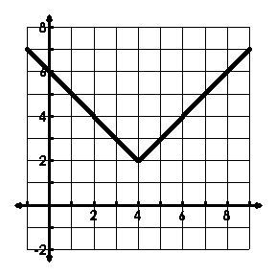
2. 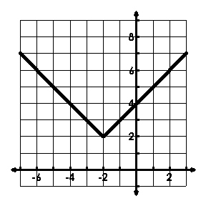
3. 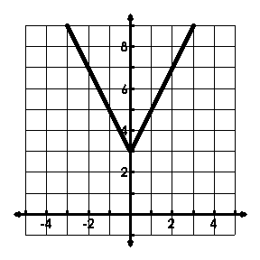
4. 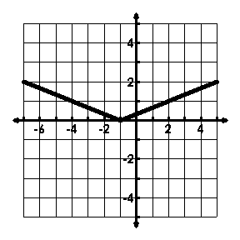
5. 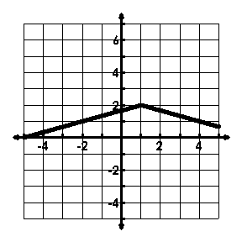
6. 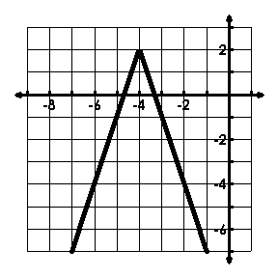

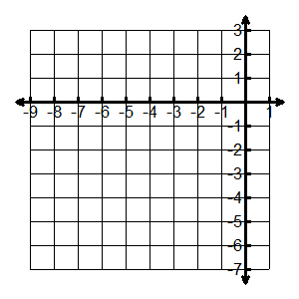Graph the absolute value function. State the vertex and the value of “a”.

1. 
2. 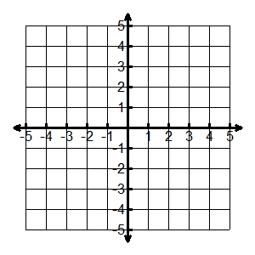
3. 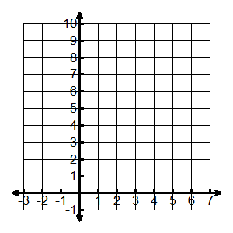
4. 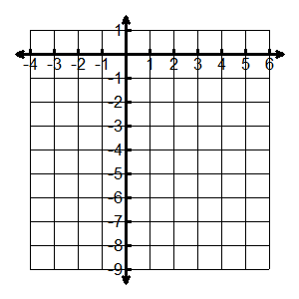

Describe the transformations.

1. 
2. 
3. 
4. 
5. 
6. 

Solve the following equations for x.

1. 
2. 
3. 
4. 
5. 
6. 
7.  

Domain: ____________________

Range: ____________________

Pt. of Discontinuity: _______________

Increasing: _____________________

Domain: ____________________

Range: ____________________

Pt. of Discontinuity: _______________

Increasing: _____________________