Name: _____________________________________ Date: __________________________________

**Absolute Value Transformations**



* **a : _____________________________________**
* **h : _____________________________________ Vertex : ________________**
* **k : _____________________________________**

**Describe the transformations:**

1. 
2. 
3. 
4. 

**Graph the following absolute value functions using transformations**

1. 

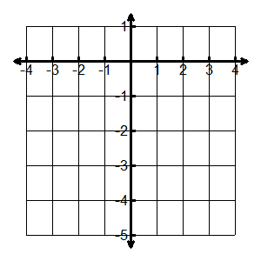

1. 



Vertex ___________ Vertex ___________

Transformations: Transformations:

**Write the equation of the absolute value given the graph.**

1. f(x) = ____________________

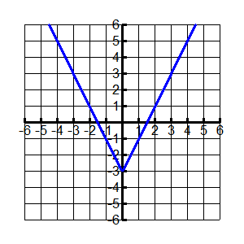

1. f(x) = ____________________

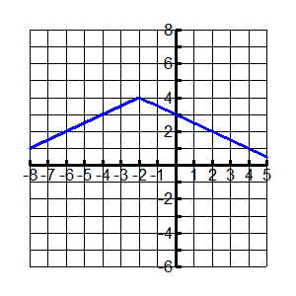

Vertex _________

a: _______

Vertex _________

a: _______

**You try!! Write the equation of the absolute value given the graph.**

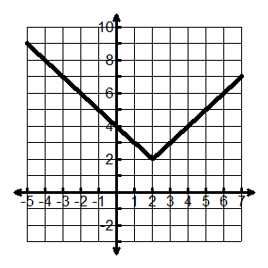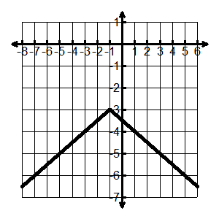





f(x) = ___________________

f(x) = ___________________

**Solving Absolute Value Equations: **

* Isolate the absolute value, then split into 2 equations:  or 
* ALWAYS check for extraneous solutions!

1. Solve for x: 
2. Solve for x: 
3. Solve for x: 
4. Solve for x: 
5. Solve for x: 
6. Solve for x: 