1. Factor: 

1. Find the remainder: 
2. If 4, , and 2 are roots of a quartic polynomial, what is the other root?
3. Describe the end behavior of . 
4. Find all the zeros of 
5. **Sketch** a graph of a polynomial with the zeros x = -3, 0, 1, 1
6. Solve: 
7. Find the values for which the functions is undefined 
8. Simplify 
9. Add 
10. Divide
11. Solve 
12. Find the hole 
13. Find the equation of the slant asymptote

of 

1. Find the x-intercepts and the y-intercept

of 

1. Determine the horizontal and vertical asymptotes of 
2. 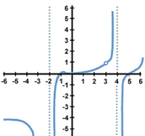Find the domain and range of the function.
3. Find the domain and range of



1. Solve 
2. Find the starting point of



1. Solve 
2. Condense the following: 
3. Graph the function and state the domain and range: 



1. The number of bacteria N in a culture is given by the model where t is in hours. Find the number of bacteria after 6 hours.
2. Solve: 
3. Solve: 
4. If $1800 is invested at a rate of 14% compounded continuously, Find the balance in the account after 8 years.
5. Identify if the following are increasing or decreasing.
   1. 

* 1. 
  2. 

1. Solve: 
2. Write the standard form of the equation of an exponential function with a base of 10, , that has been reflected over the x-axis, shifted right 3, and down 5.
3. What are the solutions of the equation 
4. Simplify the fraction 
5. Solve the equation: 
6. Use the quadratic equation to solve the following: 
7. What number would we need to add to  if you want to complete the square?
8. Find the x-intercepts for the following equation: 
9. A normal distribution has a mean of 25 and a standard deviation of 5. Draw the normal curve and find the probability between 10 and 25.
10. A normal distribution of ACT scores has a mean score of 18 and a standard deviation of 6. Within what range do about 68% of the scores fall?
11. List the 6 types of Sampling Methods (be able to give an example of each)
12. 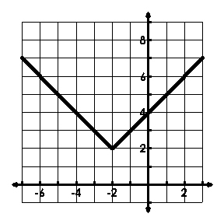Where is the graph

decreasing?



1. Find the sum of the first 10 terms of the

sequence -2, -6, -18, -54, ….

1. Graph 

