Name: _______________________________ Self-Progress Check
Simplify and identify the x-values for which the expression is undefined.
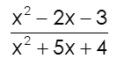
1)

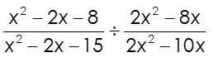
2)

